**Vision Based Automation**

**Name: Vivek Chandrashekhar Rugale**

**GR No.: 11810369**

**Div.: TY-C**

**Roll No.: 24 (Batch B1)**

**LAB 3: Object segmentation using spatial features.**

Otsu Thresholding-

# -*- coding: utf-8 -*-

"""

Created on Mon Sep 21 14:36:47 2020

@author: VIVEK RUGLE

"""

import cv2

import numpy as np

from matplotlib import pyplot as plt

img = cv2.imread('tree.jpg',0)

thresh1 = cv2.adaptiveThreshold(img, 255, cv2.ADAPTIVE_THRESH_MEAN_C, cv2.THRESH_BINARY, 199, 5)

thresh2 = cv2.adaptiveThreshold(img, 255, cv2.ADAPTIVE_THRESH_GAUSSIAN_C, cv2.THRESH_BINARY, 199, 5)

plt.subplot(131),plt.imshow(img,cmap = 'gray')

plt.title('Input Image'), plt.xticks([]), plt.yticks([])

plt.subplot(132),plt.imshow(thresh1, cmap = 'gray')

plt.title('Adaptive Mean'), plt.xticks([]), plt.yticks([])

plt.subplot(133),plt.imshow(thresh2, cmap = 'gray')

plt.title('Adaptive Gaussian'), plt.xticks([]), plt.yticks([])

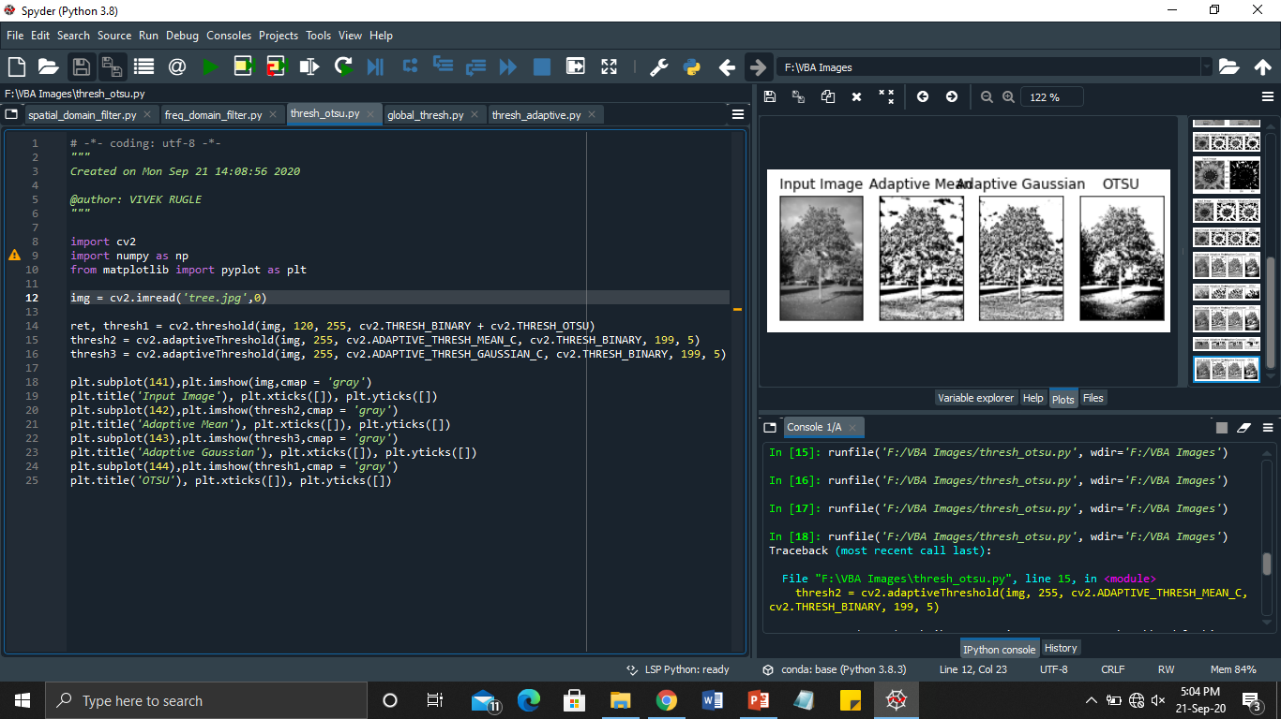

Global Thresholding –

# -*- coding: utf-8 -*-

"""

Created on Mon Sep 21 14:27:56 2020

@author: VIVEK RUGLE

"""

import cv2

import numpy as np

from matplotlib import pyplot as plt

img = cv2.imread('tree.jpg',0)

ret, thresh1 = cv2.threshold(img, 150, 255, cv2.THRESH_BINARY)

plt.subplot(121),plt.imshow(img,cmap = 'gray')

plt.title('Input Image'), plt.xticks([]), plt.yticks([])

plt.subplot(122),plt.imshow(thresh1, cmap = 'gray')

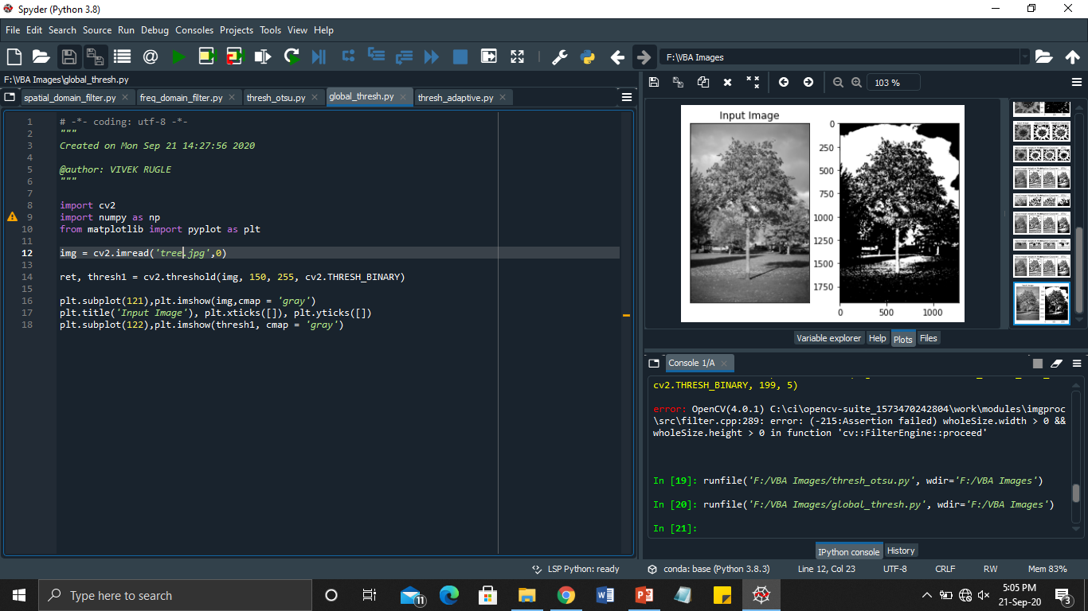

Adaptive Thresholding –

# -*- coding: utf-8 -*-

"""

Created on Mon Sep 21 14:36:47 2020

@author: VIVEK RUGLE

"""

import cv2

import numpy as np

from matplotlib import pyplot as plt

img = cv2.imread('tree.jpg',0)

thresh1 = cv2.adaptiveThreshold(img, 255, cv2.ADAPTIVE_THRESH_MEAN_C, cv2.THRESH_BINARY, 199, 5)

thresh2 = cv2.adaptiveThreshold(img, 255, cv2.ADAPTIVE_THRESH_GAUSSIAN_C, cv2.THRESH_BINARY, 199, 5)

plt.subplot(131),plt.imshow(img,cmap = 'gray')

plt.title('Input Image'), plt.xticks([]), plt.yticks([])

plt.subplot(132),plt.imshow(thresh1, cmap = 'gray')

plt.title('Adaptive Mean'), plt.xticks([]), plt.yticks([])

plt.subplot(133),plt.imshow(thresh2, cmap = 'gray')

plt.title('Adaptive Gaussian'), plt.xticks([]), plt.yticks([])

